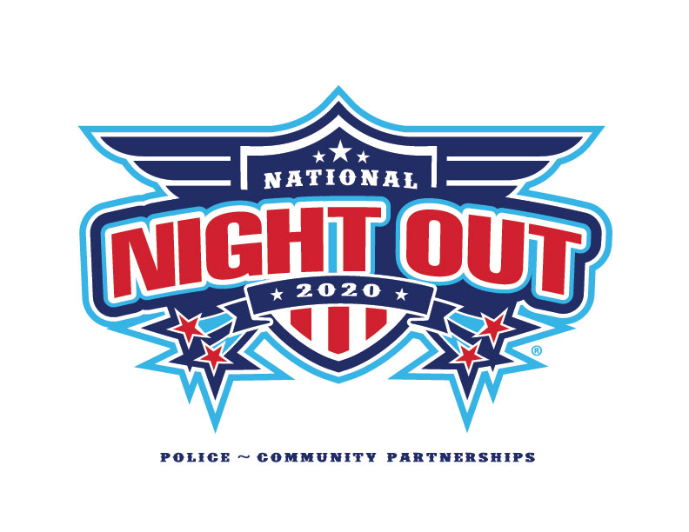
Simple Ways to go Green at a Block Party

Event Type Overview:
Types of activities: Potluck/barbeque, information tables, games, and other activities.
Reduce & Reuse
- When possible, email information about your event to attendees to cut down on paper use.
- Provide condiments in bulk instead of individually wrapped servings. For example, provide bottles of ketchup instead of individual packets. Buy other products in bulk whenever possible.
- Only serve food and beverages in washable or recyclable containers. If you don’t have enough reusable cups, plates or silverware, ask people to bring their own.
- Use decorations that can be reused in future years, and limit or don’t use balloons.
- Consider using a reusable banner and not including the event year so it may be used again.
Recycle
- Provide recycling bins for cans, bottles, and other recyclables that may be produced at your event. Simply roll out your cart from your home or borrow event recycling bins from Anoka County
(763) 324-3400. Extra recyclables can be brought to the Recycling Center, call Public Works to arrange.
- Close the loop, purchase tableware made with recycled content.
Compost
- If not using washable dishes consider using certified compostable products with a BPI logo. The City is offering these products to household parties for free. Call Public Works to order.
- Put out containers to collect food waste. Simply roll out your Yard Waste/Organic cart from your home or email publicworks@columbiaheightsmn.gov to order one.
- Borrow event organic bins from Anoka County (763) 324-3400. Extra organics can be brought to Public Works, call (763) 706-3700 to arrange.
City of Columbia Heights Public Works Department
publicworks@columbiaheightsmn.gov or (763) 706-3700

